PRESS ADVISORY

For immediate release Contact: Alexis Mendoza
347 920 6579
Luis Stephenberg
917-699-7598
Bxlatino.bienal@bluetie.com

Immigration “EXODO” is the theme of the
Second Bronx Latin American Art Biennial

Bronx celebrates 2010 Bx Latin American Art Biennial, with a program that included several Art Exhibitions, throughout The Bronx, starting September 17 at The Point. Artists address issues such as, migration and exile. This call for a rational and creative interpretation on the action of human migration, it presents particular perspectives that just art can achieved. Art works in all genres and media representing 21 different countries. It features urban installations, art performance, graffito murals, videos, painting sculptures and graphics.
While September 17th through November 30th, marks Hispanic Heritage Month, the Bronx Festival Inc. celebrates with the participation of over 100 artists local as well as from throughout the Caribbean, Mexico and Latin America.

Who:

When: Friday September 17th 2010
Opening Reception 6:00PM to 9:00PM

Where: The Point Community Development Corporation
940 Garrison Avenue,
Bronx, NY 10474,
Tel.: 718 542 4139

What: Kick-off of Bronx Hispanic Arts Festival

NOTE: See attached calendar of events

2010 Bronx Hispanic Festival Inc. Calendar of Events

1 - September 17, 2010 until October 30, 2010 - “No Borders” presents artists who have a long term relationship with their subjects and who widely used different mediums to break down barriers of neighborhood, family, identity and class. These artists comment on ideas of separateness and merge into or comment on marginalized communities or individuals. Artists often choose to live in marginalized communities out of economic necessity and do not fit within a specific class structure but rather come from every background imaginable. They are drawn to life on the margins as it represents a distancing from the norm and allows for more freedom of thought and action.

ARTISTS:
Adelia Sayeg, Arturo Parra, Bernardo Navarro, Gustavo Tavares, Hamlet Surita, Hatjey Ramos Fermin, Juan Fernando Figueroa, Josei Gonzalez, Jorge Mendoza, Moses Ross, Patricia Enrique, Raul Villareal, Saroska, Sylvia Padilla, TATSCRU.
CURATORS:
Alexis Mendoza, Luis Stephenberg and Miguel Lescano

Directions:
By Subway: Take the 6 train to Hunts Point Avenue. Walk under the Bruckner Expressway (right in front of you when you exit the train station onto Hunts Point Avenue) and make a right turn at the first light onto Garrison Avenue. THE POINT is on the corner of Garrison and Manida Street (the first street on your left walking on Garrison). The entrance is on Manida Street.

By Car: Take the FDR Drive to the Willis Avenue Bridge. Bear right on Bruckner Boulevard (and stay under the Bruckner Expressway) for 1 to 2 miles. Turn right onto Barretto Street. Turn left onto Garrison. THE POINT is located on the corner of Garrison and Manida. Park on the street. The entrance is on Manida.

Exploring Further Evidence
2- “Exploring Further Evidence” explores issues from the emphasized opinion that discusses some of the new contexts for migration globally, ideas travel, objects pass from one culture to another etc. The artists including in the show are created and capture in their own modern way the world is moving.

The artworks suggest the sense of documentation, expressing a sort of presences in events, fiction or non-fiction the archive, create a conglomerate of clues that never completely stop sending information. The artists in the show create a relationship between past and present, a form that stipulates its own shifting terms, constantly renewing and differentiating meaning from one moment to another. Some of the artists are acutely aware that they trying to capture an elegance that is quickly turning into a documentation.

When: September 18 to November 24, 2010
Opening Reception Saturday September 25th 2010
3:30PM to 6:30PM

Where: GORDON PARKS GALLERY
COLLEGE OF NEW ROCHELLE ANNEX
JOHN CARDINAL O’CONNOR CAMPUS
149th Street, Bronx New York,
Tel.: 718 665 1310, www.CNR.edu

ARTISTS:
Aixa Requena, Alejandra Delfin, Antonio Tovar, Adal Maldonado
Carolina Mayorga, Catalina Schliebener, Claudio Roncoli, Diego Marcial Rios, Elio Guevara, Guillermo Lorente, Iris Pérez Jesus Ignacio Valdez Martinez, Liliana Avalos, Luis Carle, Luis Pagan, Melanie Diaz, Pablo Caviedes, Jorge Opazo Ellicker, Rafael Carabano, Ramon Peralta, Renelio Marin, Ricardo Celma, Sonia Cunliffe, Xavier Figueroa

CURATORS:
Alexis Mendoza, Luis Stephenberg and Miguel Lescano
The show will run from September 18 to November 24, 2010

Directions:
-Subway: Train 4, 5 or 2 to E. 149th Street and Grand Concourse. Walk east two blocks.

-Bus: Grand Concourse and 149th Street #1, Morris Avenue #32, 149th Street Crosstown #19, Melrose Avenue and 150th Street, #2 and #41 Third Ave. and 149th St. #26, #31, #55 Third Ave./Westchester Ave and Webster Ave. #41

-Car: From Manhattan and Brooklyn: East River Drive Northbound to Willis Ave. Bridge. Major Deegan North (87) Exit at E. 149th St, turn right and proceed straight. From Queens : Triborough Bridge to Major Deegan (87) Northbound. Exit at 149th Street. Turn right and proceed straight. From North: Bronx River Parkway, Hutchinson River Parkway or New England Thruway Southbound to Bruckner Expressway (287) Westbound to Major Deegan Northbound. Exit at East 149th St. Turn right. Drive straight. From New Jersey: George Washington Bridge to Major Deegan (87) south. Exit at Eat 161st Street and Yankee Stadium to River Avenue. Turn right. Drive to 149th Street, make a left and keep straight.

Admission: Free

“Altered Reality” explores how individuals influence each with their behavior, culture and in doing so how people effect and shape their environment. Recent research has shown that even those peripherally around an individual shape and change that person’s behavior and habits. Taken on a larger scale, these gestures and beliefs go to construct the society we live in and shape all that is around us. The artists in “Altered Reality” take their focus from a multiplicity of vantage points, and they show the various characteristics and expressions that people put in motion in their creation of the society, of themselves and the settings that they live in.

When: Open September 12 2010 until October 30 2010
Reception October 1, 2010 from 5:30 pm to 7:30 pm

Where: Lincoln Medical and Mental Health Center
234 East 149th Street Bronx NY 10451

Artists
Michael Caballero, Luis Martin, Irene Becerril, Gido Ramacho, Steven Edmunson, Abraham, Huberto Baque, Luis Morales, Fernando Panaloza, Jose Acosta, Gabriela Trueba, Carlos Solis, Tony Morales

Directions:
-Subway: No. 6 to Third Ave. and 138 St.

-Bus: BX 1, 2, 21, 32, 33, to 138 St. and 3rd Ave. Walk west 3 blocks on Lincoln Avenue to Bruckner Boulevard, BxM 15 (Bronx /Harlem) to corner of Bruckner Blvd. and Lincoln Ave.

-Car: From FDR North to Willis Ave. Bridge. Left on 135 St. Left on Lincoln Ave. Drive 3 blocks west to Bruckner Blvd. From Major Deegan Expressway / 87 South Exit 2 / East 134 St. Right under Willis Ave. Right to Bruckner Blvd. Drive 2 blocks north to Lincoln Ave.

Admission: Free

4- The wall, the inclusion of graffito mural in the 2010 biennial edition created by Sandro Figueroa (Sand2) is an expansion of urban expression persistent in the Bronx area for many years. The work can be seen when you travel on train number six, starting September 29, 2010

Where: Da Bakery Gallery
1700 Southern Blvd. Bronx N.Y. 10460

Performance Art at The Bronx Museum
5- Brazilian artist Angela Freiberger will performs FREE starting at 5:45 pm
Angela Freiberger explores the idea of 'body', in which the sculpture and other media suggest and become an extension of her. The sculptures represent and contrast the finitude of the human body. She incorporates performance art to challenge and transgress physical and mental boundaries.

Puerto Rican artist Alicia Grullon will performs Illegal Death starting at 4;00pm
Alicia Grullón is interested in the affect place has on identity, the politics of living and the body as word. Her projects consist of performances and photography in public spaces where everything accidental and local become setting and character.

When: Wednesday October 6: Art Performance

Where: Bronx Museum of Art 1040 Grand Concourse Avenue,
Bronx, NY 10456 Tel. (718) 681-6000

6- Brazilian artist Angela Freiberger will performs FREE starting at 1:45 pm
Fallowing with a symposium at the museum
October Sunday:

7- International Venue Place on no place
This exhibit celebrates not only the richness of the Latin American art but also the diversity in the arts in the global context. Calling for an Intervention this venue included artist participation from any part of the world. Is an out door location

When: Saturday October 16, 2010
Where: The Point Campus at Bronx River Shore in Hunt Point, Bronx

8- October18, 2010 will began the Open view display window at the 161 Street Court House side walk level. This venue included large size works and installations.
Artist
Rigo Peralta, Pedro Velez, Eduardo Terranova, Raul Villa Real, Diogenes Ballester, Carlos Vasquez, Amura Chiza

9- Chilenian Sebastian Mahaluf performance Nomad V
Eternal Jump penultimate performance, space intervention with
Silver- plated elastic stone suit. Visual and performance artist has exhibited his work Worldwide, in countries such as Chile, China, America and Argentina. Throughout his many projects he concentrates on the significance of geometry and shape, as well as the interaction of the human body. Previous visions from Sebastian have scalped from wearing a stone suit for a performance piece to using 5000 meters of golden elastic in an installation, define as “AREA”

When: Wednesday November 3 2010 Art Performance 5:30 pm
Where: at the Bronx Museum of Art at 1040 Grand Concourse Avenue, Bronx, NY 10456 Tel. (718) 681-6000

10 - “RECONSTRUCTION ELSE WHERE”, Group Exhibition.
November 6, 2010Artist’s Reception,”
Time: 3:00 pm –6:00 pm.
Location: BRONX ART Space
305 East 140th Street, Bronx NY, 10454
Tel.: 718 772 4961 www.bronxartspace.com

“Reconstruction Elsewhere” deals with parallel realities in artists work either in its formal or conceptual qualities. A parallel reality is a state that we are continually in and that we are regularly experiencing. In each year, day or hour we encounter a barrage of contradicting and colliding attitudes, thoughts, sensations, desires, emotions and dreams. This condition is even more heightened for artists as they experience parallel realities as immigrants and as artists in the conceptualization and in the creation of their work, exploring the many subtleties and shapes of survival and transformation using all manner of media, from painting to video and performance.

Artists
Amarris Betancourt, Carlos Fajardo, Alberto Borrea, Julio Justo, Pepe Coronado, Lissette Solorzano, Margarita Fresco, Marisol Diaz, Milton Afanador
Niurka Barroso, Rosa Tavarez, Sebastian Garcia, Gabriela Treba, Pablo Jansana, Miguel Lescano, Juan Sanchez, Diogenes Abreu, Roberto Huarcaya, Jaime Higa , Pilar Pedroza , Angie Bonino, Raul Lopez Garcia, Radames Mejias, Ines Tolentino, Ismael Checo, Danny Peralta, Kevin Gerien, Jesus Rivera, Alain Gutierrez, Rafael Rosario

Directions:
By Subway: 6 Train to 138th Street/3rd Ave – note there are two exits to the subway station, at 3rd Ave and at Alexander Ave.

Admission: Free

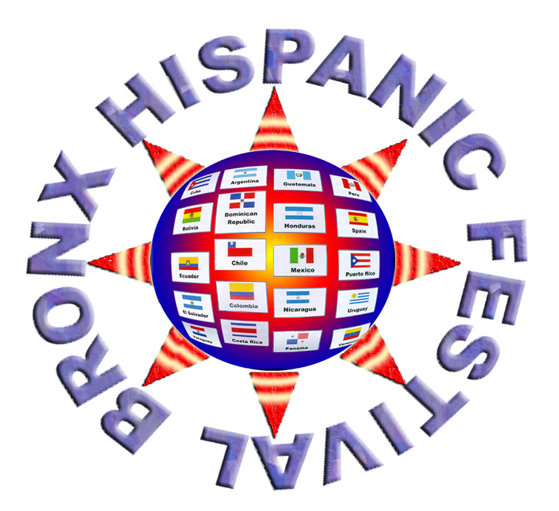
Bronx Hispanic Festival Inc. Po box 1765 Bronx NY 10451
